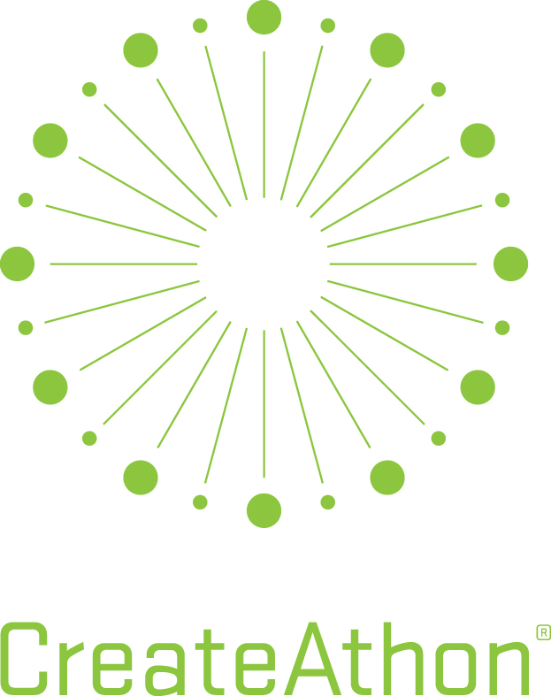
750 Meeting Street
West Columbia, SC 29169
803.799.5972 T
803.779.8447 F
www.riggspartners.com

Riggs Partners 2019 CreateAthon Application

GENERAL INFORMATION

Organization Name:
Address:
Contact Name/Title:
Phone:
E-Mail Address:

ORGANIZATION INFORMATION

Please describe the organization’s mission.

Is your organization listed as a 501(c)(3)? | Yes |  | No
501(c)(3) Number (Only 501(c)(3)-designated nonprofits are eligible.)
What year was the organization founded?
Where is the organization headquartered?
What is your service area?
Does your organization provide direct services or is it an association/coalition?
Did your organization budget for marketing or public relations expenditures this year? | Yes |  | No
If yes, how much? | $

Is your organization currently working or planning to work with any other  marketing or public relations firm on a paid or pro bono basis? | Yes |  | No
If yes, who?
Is your organization working with any other type of paid consultant? | Yes |  | No
If yes, who?
Has your organization applied for CreateAthon previously? | Yes |  | No
Has your organization been selected as a recipient? | Yes |  | No

MARKETING AND COMMUNICATIONS OBJECTIVES

Describe the primary issues or needs affecting your organization that you believe effective marketing and communications can help to solve (in detail, please!)

CREATIVE DELIVERABLES

In order of priority, provide a description of any specific projects you’d like us to consider producing. Examples include brand strategy or messaging development; marketing/PR strategy; fundraising case for support; logo refresh or redesign; letterhead package; commercial or video storyboard; poster; website plan; content or production; social media program; and others.

Describe each project as indicated. Feel free to add additional projects or details.

Project One – Urgent Priority

Project Description:

What need will this address:

Who is the intended audience?

Is the project tied to a specific timeframe or event date?

What will make this a success for you?

Please share any insights to assist with production.

Project Two – High Priority

Project Description:

What need will this address:

Who is the intended audience?

Is the project tied to a specific timeframe or event date?
What will make this a success for you?

Please share any insights to assist with production.

Project Three

Project Description:

What need will this address:

Who is the intended audience?

Is the project tied to a specific timeframe or event date?

What will make this a success for you?

Please share any insights to assist with production.
Project Four

Project Description:

What need will this address:

Who is the intended audience?

Is the project tied to a specific timeframe or event date?

What will make this a success for you?

Please share any insights to assist with production.

Please add additional projects to your scope as needed.

PRODUCTION RESOURCES

Which board members or key decision makers within the organization will provide project input and review/approve the work?

Name | Title
1.
2.
3.
4.
5.
6.
7.
8.
9.
10.

Are these individuals able to attend both a scheduled planning meeting prior to the event, and a presentation at Riggs Partners the morning of Friday, Oct. 18? | Yes |  | No
Do you have a marketing or communications director or other staffer to coordinate follow-up production such as printing? | Yes |  | No
If yes, who?
Resource or vendor for website development or email marketing? | Yes |  | No
If yes, who?
Resource or vendor for public relations or social media tactics? | Yes |  | No
If yes, who?
Pre-existing resource, vendor or arrangements for free media space? | Yes |  | No
If yes, who?

RIGGS PARTNERS CREATEATHON 2019 SELECTION PROCESS

Application Deadline to Riggs Partners: | July 15, 2019
Selected Candidates Notification: | August 30, 2019
Submit your completed application to:
Via USPS
Riggs Partners
Attn: Yanti Pepper
750 Meeting Street
West Columbia SC 29169

Or

Via eMail
yanti@riggspartners.com

RIGGS PARTNERS CREATEATHON 2019 TERMS AND CONDITIONS

Riggs Partners will not produce work via CreateAthon that is being handled or coordinated by any type of paid consultant on behalf of the nonprofit organization or tied to initiatives under the purview of other paid consultants.

If my organization is selected for CreateAthon, I understand and agree to the following:

- Riggs Partners will complete project work between the hours of 8:00 am Thursday, October 17, 2019 and 8:00 am Friday, October 18, 2019.
- We will meet with Riggs Partners staff in the firm’s office prior to CreateAthon (date to be determined) to provide background on the organization and any requested project(s). Riggs Partners will develop a strategic brief outlining work to be created during CreateAthon. The brief will be approved and signed by you prior to the start of CreateAthon.
- We will meet the CreateAthon project team at Riggs Partners on the morning of Friday, October 18, 2019 for a presentation of strategic and creative marketing deliverables. A specific appointment time will be scheduled.
- We will meet with Riggs Partners staff in the firm’s office during the week of October 21, 2019 to provide any changes or edits required to conclude the project. A specific appointment time will be scheduled.
- Riggs Partners will provide no additional work beyond the terms outlined above.
- Work completed during CreateAthon is the property of Riggs Partners and any third parties, such as photographers, illustrators, etc., that contribute to the projects.

☐ I have read and agree to the terms and conditions listed above.

Name of Organization:
Contact Name:
Title:
Signature:
Date:

If you have any questions, please contact Yanti Pepper at (803) 799-5972 x616.

